**Details of your portfolio**

PD URL site *(*Compulsory to fill up for milestone 2 and 3):*

*Live link/URL of your PD site*

Name of your portfolio:

*Kaera Barber’s portfolio*

Your Logo:



Describe your target audience:

*My target audience for this website are future employers, industry professionals and potential collaborators in the industry that I am studying in which is design and development. The age range of the target audience is around 20-45 years old, are likely based in Singapore and value innovation, aesthetics and purpose-driven design. They are usually involved in fields like graphic design, UI/UX and programming and are looking for emerging designers who can bring fresh ideas to the table.*

Describe your brand story/ purpose:

*I am a student studying digital design and development, passionate about creating meaningful and visually engaging designs. My interest in design began with a love of creating and storytelling and it has evolved into a deeper interest and understanding on how different elements and components work together to send a message. My goal is to present myself as a thoughtful and versatile designer that resonates with my target audience.*

**Design brief**

Colour scheme & Colour palette:

*I have decided on a monochromatic colour scheme which includes shades of brown with small pops of brighter colours to help draw attention to important points of the website.*

*Here is a base colour scheme:*

Typography:

**Montserrat**

**Open Sans**

Theme:

*Minimalistic scrapbooking*

Layout/ Arrangement:

Opening page

Home

About

Contact

Portfolio

Development work

Design work

Selected work

**Low fidelity wireframe:**

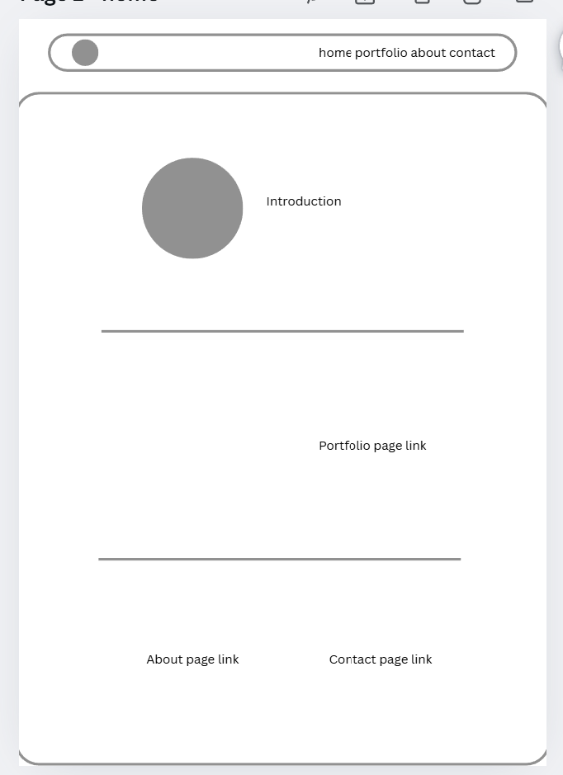

**High fidelity wireframe** *(*Compulsory to fill up for milestone 2 and 3)***:**

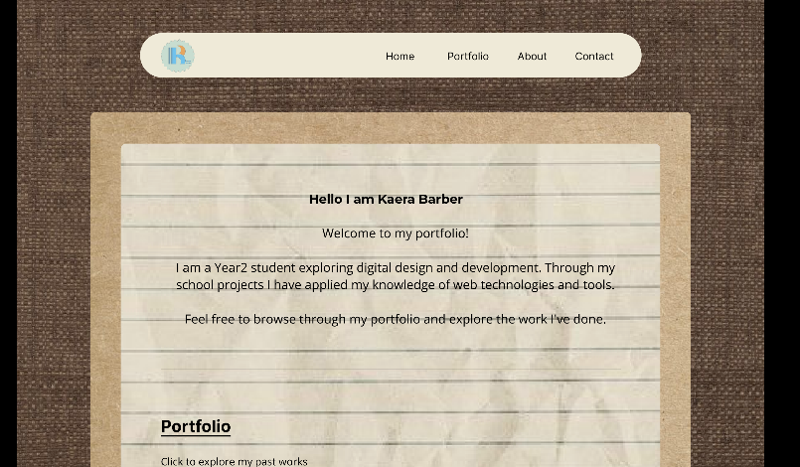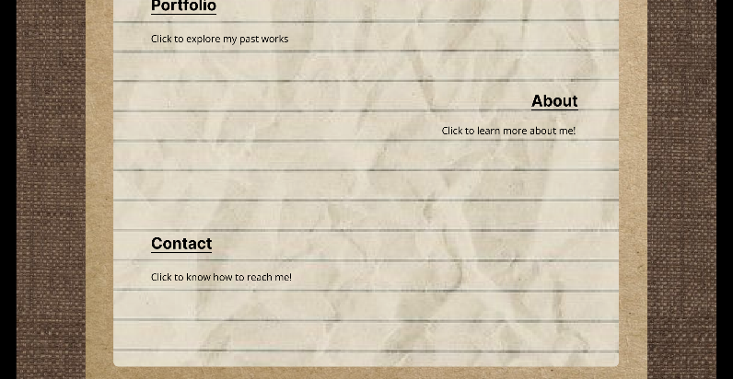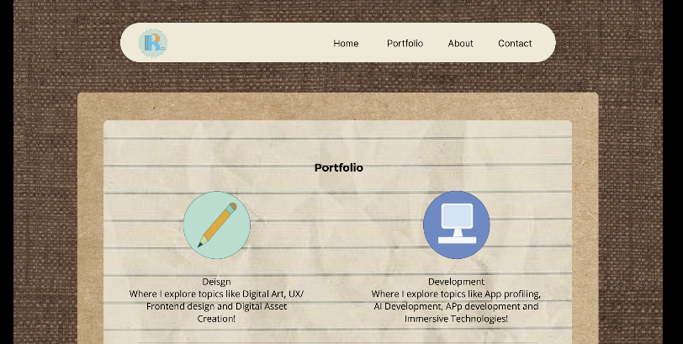

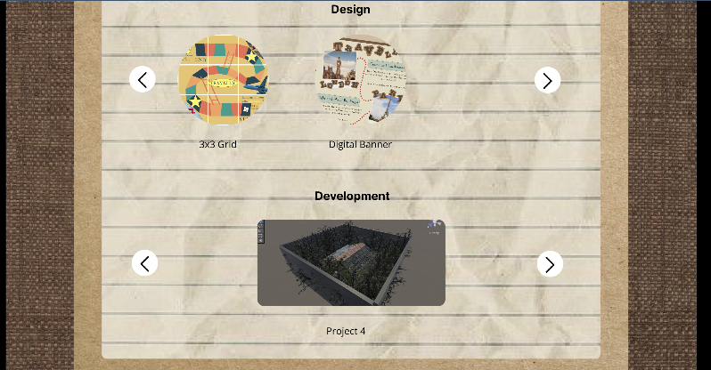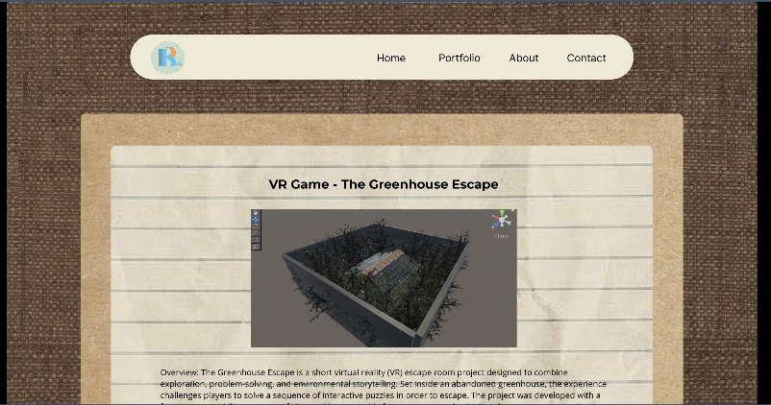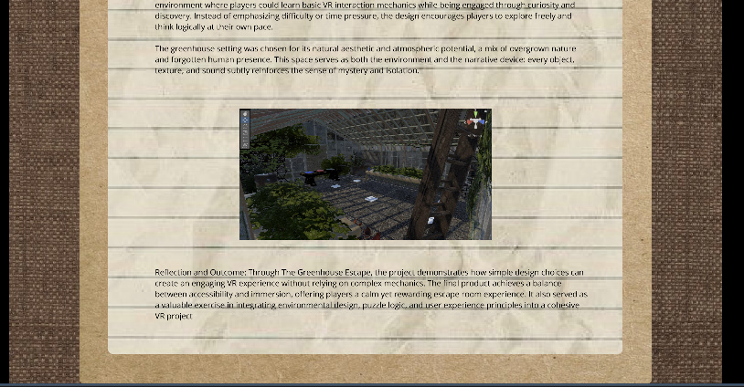

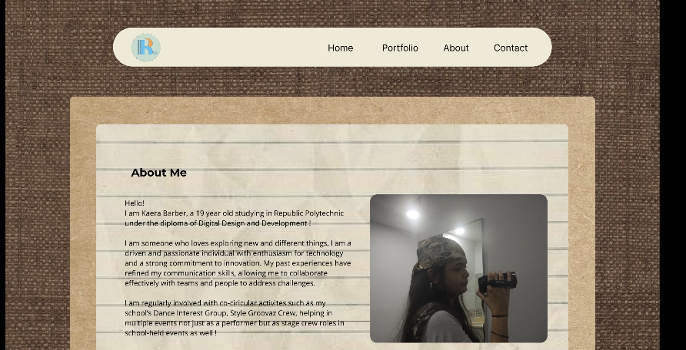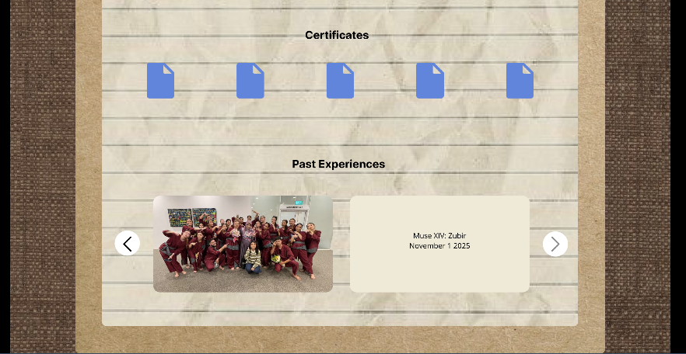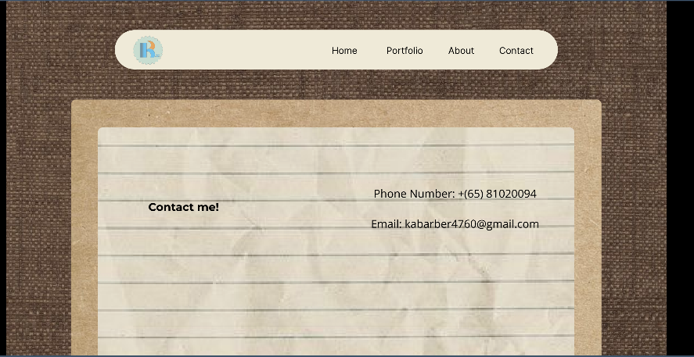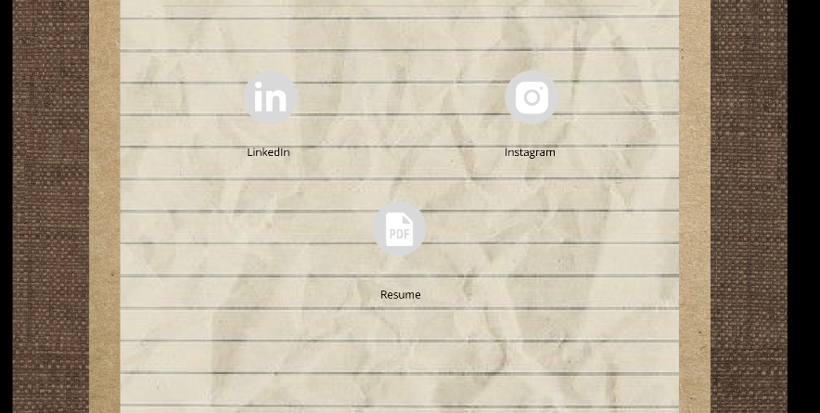

**Link to your Prototype – Most likely on Figma (make sure your lecturer is given access to the site)** *(To fill up for milestone 2 and 3)***:**

*https://www.figma.com/design/aF5TyN6LiG770jrcC1ony3/C218-CA1_23031962--Copy-?node-id=22-101&t=13WQX0KZsplSUqKe-1*